**Project 01_05_02**

In this project, you will create a function that opens a confirmation window when a user clicks a button. The window you create will be centered on the user’s screen. You will then enhance it to close the confirmation window 5 seconds after it opens. You will then replace the timeout with a close button.

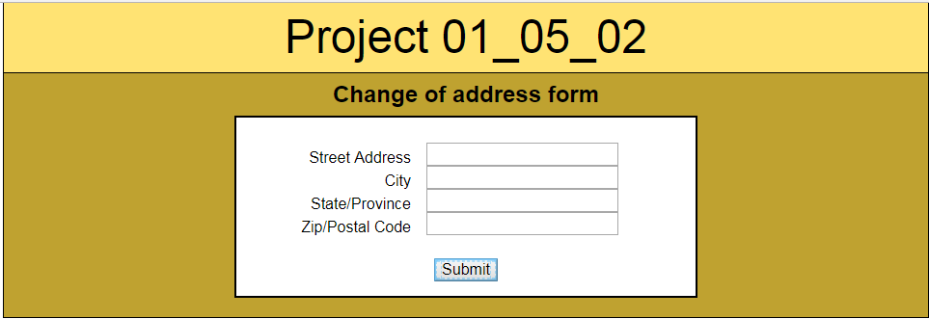 

1. Copy all of the completed files from Project 01_05_02.zip into a Project 01_05_02 folder; this will contain all of the files you will zip up and submit. Open all of the necessary files in your IDE and complete the documentation at the top.
2. Got to the ***index.html*** file and add a ***<script>*** element just before the closing ***</head>*** tag:  
    ***<script type="text/javascript" src="confirm.js"></script>***
3. Save the file and create a new JavaScript file, ***confirm.js***. Add all of the appropriate documentation to the top of the file, with your name and the date. Add the following function to the file:  
   ***function processInput() {  
    var propertyWidth = 300;  
    var propertyHeight = 100;  
    var winLeft = ((screen.width - propertyWidth) / 2);  
    var winTop = ((screen.height - propertyHeight) / 2);  
    var winOptions = "width=300,height=100";  
    winOptions += ",left=" + winLeft;  
    winOptions += ",top=" + winTop;  
    window.open("confirm.html", "confirm", winOptions);  
   }***  
   Save the file and run ***index.html*** in the browser. Open the Developer Tools and make sure that everything looks good and there are no Console errors.
4. At the bottom of ***confirm.js***, let’s add a function that will attach ***processInput()*** as an event handler:  
   ***function createEventListener() {  
    var submitButton = document.getElementById("submit");  
    if (submitButton.addEventListener) {  
    submitButton.addEventListener("click", processInput, false);  
    }   
    else if (submitButton.attachEvent) {  
    submitButton.attachEvent("onclick", processInput);  
    }  
   }***  
   Save the file and run ***index.html*** in the browser. Make sure that everything looks good and there are no Console errors.
5. At the bottom of the script, let’s add some code to attach the event listener when the page loads:  
   ***if (window.addEventListener) {  
    window.addEventListener("load", createEventListener, false);  
   }   
   else if (window.attachEvent) {  
    window.attachEvent("onload", createEventListener);  
   }***Save the file and run ***index.html*** in the browser. Make sure that everything looks good and there are no Console errors. One thing to note, Chrome has a weird bug and ignores the ***left*** option if running on a second monitor.
6. In confirm.js, before the ***processInput()*** function, let’s enable ***strict*** JavaScript and set a ***global*** variable as follows:  
   ***"use strict";  
   var confirmWindow;***
7. In the ***processInput()*** event handler, set the ***confirmWindow*** variable as the return from the window.open() function. Then let’s set a 5 second ***timeout*** to close the confirm window as the next statement:  
    ***confirmWindow = window.open("confirm.html", "confirm", winOptions);  
    setTimeout("confirmWindow.close()", 5000);***  
   Let’s give this a good browser test and make sure the confirm window automatically shuts down.
8. Now let’s add a ***Close*** button to the confirm window. Open ***confirm.html***, and add a new ***<p>*** element below the existing ***<p>*** element:  
    ***<p id="closeB">Close</p>***  
   Let’s give this a browser test and make sure it shows up.
9. Just below the closing ***</body>*** tag, insert a ***<script>*** tag. Inside it, let’s build a ***closeWindow()*** event handler function:  
   ***<script type="text/javascript">   
    function closeWindow() {  
    window.close();  
    }  
   </script>***
10. Attach the new event handler to the ***Close*** button by building a ***createEventListener() function***:  
     ***function createEventListener() {  
     var closeButton = document.getElementById("closeB");  
     if (closeButton.addEventListener) {  
     closeButton.addEventListener("click", closeWindow, false);  
     }   
     else if (closeButton.attachEvent) {  
     closeButton.attachEvent("onclick", closeWindow);  
     }  
     }***Give this a good browser and Developer Tools test.
11. Let’s finish this off at the bottom of the script by attaching the ***createEventListener()*** event handler on window ***load***:  
     **/* run createEventListener() function when page finishes loading */  
     if (window.addEventListener) {  
     window.addEventListener("load", createEventListener, false);  
     }   
     else if (window.attachEvent) {  
     window.attachEvent("onload", createEventListener);  
     }**Let’s give this a final test. When it is clean, zip it up.